**Computer Engineering Department**



**Faculty of Engineering**

**Cairo University**

**Modeling & Simulation**

**Lab #1**

**Problem:**

Arrivals of people at a telescope exhibit follow an exponential distribution of mean ***a***minutes. Only one person can see the exhibit at a time. Time taken by one person to see the exhibit follows an exponential distribution of mean ***s***minutes. A person can buy a ‘privilege’ ticket for L.E. 30 which gives him/her priority in queue over those who don’t have a privilege ticket. 50% of the visitors are willing to pay and get a privilege ticket, but they make their decision to do so only if one or more people are in queue when they arrive (another person is waiting to be served). The exhibit is open continuously from 10 am to 4 pm (last arriving visitor will arrive before 4pm, visitors in the queue will be served even after 4pm).

Simulate ***n* replications** of the operation of the system, each replication has length of **one complete day** and report the following statistics:

1. Profit gained through sale of privilege tickets

2. Average waiting time of an exhibit visitor

3. Average waiting time of an exhibit visitor with a privilege ticket

4. Average waiting time of an exhibit visitor without a privilege ticket

Your simulator should take as input (keyboard input) ***n***, ***s***and ***a***and should report the required statistics (averaged across all *n* replications). The model is to be coded in **C/C++/C#** or **Java**. You are not allowed to use any special purpose simulation language nor simulator (Matlab is not allowed).

**Hint**:

In [probability theory](https://en.wikipedia.org/wiki/Probability_theory) and [statistics](https://en.wikipedia.org/wiki/Statistics), the **exponential distribution** is the [probability distribution](https://en.wikipedia.org/wiki/Probability_distribution) of the time between events in a [Poisson point process](https://en.wikipedia.org/wiki/Poisson_point_process), i.e., a process in which events occur continuously and independently at a constant average rate [Wikipedia ] ,for more information visit <https://courses.lumenlearning.com/introstats1/chapter/the-exponential-distribution/>

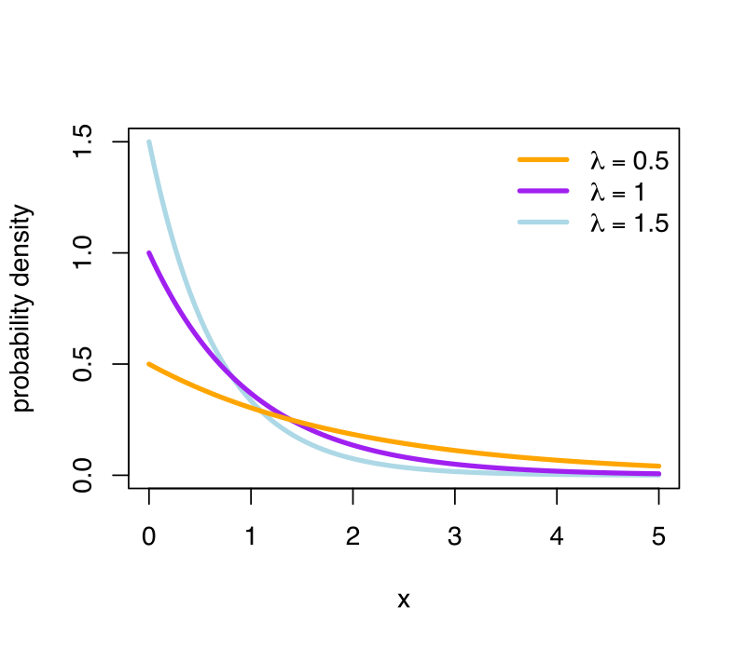

You can generate exponential distribution of mean ***a***from uniform distribution U [0, 1] using the following equation:

$X= \frac{log (1-U)}{(- λ)}$ where $λ=\frac{1}{a}$

**Test Cases:**

n=1000, s=1.1 mins, a=1 mins =>

Av. waiting for all = 14:10 mins

Av. waiting for privilege = 2:24 mins

Av. waiting for without-privilege= 26:15 mins,

n=1000, s=0.5 mins, a=0.5 mins =>

Av. waiting for all = 5::20 mins

Av. waiting for privilege = 0::59 mins

Av. waiting for without-privilege= 8::39 mins

(note 5::20 mins means 5 mins and 20 seconds)